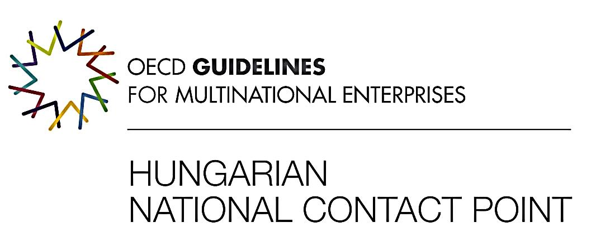
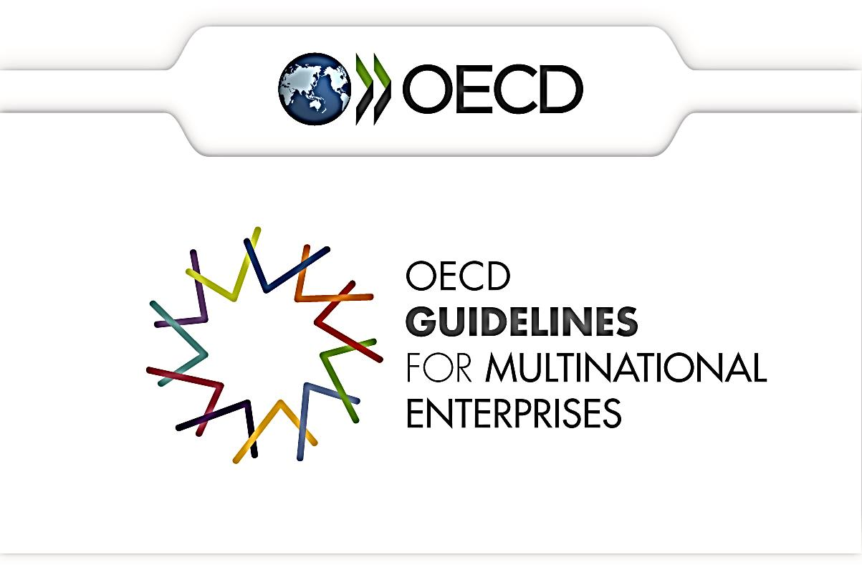

RBC & CSR CONFERENCE

BUDAPEST CONFERENCE ON

RESPONSIBLE BUSINESS CONDUCT & COMPETITIVENESS

OECD GUIDELINES FOR MULTINATIONAL ENTERPRISES

&

CORPORATE SOCIAL RESPONSIBILITY

27-28 January 2020

VENUE: MINISTRY OF FINANCE

PÉNZTÁRTEREM

1051 BUDAPEST, JÓZSEF NÁDOR TÉR 2-4.

Program

JANUARY 27, 2020

With the participation of
the OECD Secretariat, the European Commission, NCPs, multinational companies, academy, professional organisations and Hungarian stakeholders

Chair: Mr. László BALOGH, Chair of the OECD Hungarian National Contact Point, Deputy State Secretary for Fiscal Policy, Ministry of Finance

Morning session

OECD Guidelines for Multinational Enterprises Responsible Business Conduct and Competitiveness

8:30 – 9:00 Registration and morning coffee

9:00 – 9:10 Welcome Address: Responsible Business Conduct and Competitiveness, OECD Guidelines for Multinational Enterprises – Gion Gábor State Secretary for Financial Policy Affairs, Ministry of Finance / Mr. László BALOGH, Chair of the OECD Hungarian National Contact Point, Deputy State Secretary for Financial Policy Affairs, Ministry of Finance

9:10 – 9:25 Opening Address: Responsible Business Conduct - Ms. Christine Kaufmann, Chair of the OECD Working Party on Responsible Business Conduct / Mr. László BALOGH, Chair of the OECD Hungarian National Contact Point, Deputy State Secretary for Financial Policy Affairs, Ministry of Finance

9:25 – 9:40 OECD Guidelines for Multinational Enterprises & the OECD NCP Network - Kathryn DOVEY, Manager of OECD National Contact Point coordination, OECD Secretariat

9:40 – 10:25 NCPs handling specific instances - how to benefit from mediation? – 5 minutes initial presentation before opening the floor for the panel discussion - OECD Secretariat
Panel discussion on cases handled by NCPs
Moderator OECD Secretariat/Chair of the Working Party on RBC
Participants: NCPs, OECD Secretariat/ Chair of the Working Party on RBC, (professional organization on mediation)
10:25 – 10:45 Q & A

10:45 – 11:15 Coffee break
11:15 – 11:30 Effective implementation of the OECD MNE Guidelines
OECD Due Diligance Guidance on Responsible Business Conduct – Presentation - OECD Secretariat Mr. Tyler GILLARD/ Ms. Barbara BIJELIC
11:30 – 12:10 Panel discussion on due diligence in practice
Moderator: OECD Secretariat/Chair of the Working Party on RBC
Participants: OECD Secretariat, NCPs, German-Hungarian Chamber of Industry and Commerce/ Hungarian Chamber of Commerce and Industry, multinational companies
12:10 – 12:30 Q & A

12:30-14:00 Lunch

Afternoon session

Corporate Social Responsibility

14: 00 – 14:10 Governmental approaches on supporting Corporate Social Responsibility and Public Social Responsibility in Hungary - Mr. Zoltán István Marcinkó Ministry of Finance, Deputy state secretary for Corporate relations and labour market

14:10 – 14:25 EU policy on Corporate Social Responsibility - Ms. Sarah GONDY / Ms. Alexandra KUXOVA, European Commission

14:25 – 14:55 Business, trade union and civil society perspective - Stakeholders’ presentations or panel discussion – Hungarian participants
14:55 – 15:10 Q & A

15:10 – 15:25 What are firms expecting from the Government regarding CSR? Results of a CSR Research conducted in 2018 –Ms. Zsófia Lakatos Hungarian Public Relations Association

15:25- 15:45 Coffee break

15:45 – 16:15 Awards- as motivation for RBC / CSR - dr. Klára Molnár, Effekteam managing director; Követ Association, Director; Károly Bognár, counsellor SEED; Takács Júlia, CSR Hungary CEO
16:15 – 16:35 Q & A

16:35 – 16:45 Closing remarks - Mr. László BALOGH, Chair of the OECD Hungarian National Contact Point, Deputy State Secretary for Financial Policy Affairs, Ministry of Finance / László Turóczy Ambassador - Permanent Representation of Hungary to the OECD

January 28 , 2020

CEE Regional Network workshop & peer learning meeting of CEE National Contact Points
Open event for CEE NCPs, invited NCPs, OECD Secretariat

VENUE: MINISTRY OF FINANCE

PÉNZTÁRTEREM

1051 BUDAPEST, JÓZSEF NÁDOR TÉR 2-4.

_____________________________________________________________

Sessions

With participation of CEE NCPs, invited NCPs and the OECD Secretariat

9:00 – 9:30 Networking Morning Coffee & discussion

9:30 – 11:00

11:00 – 11:30 Coffee

11:30 – 13:00

13:00 Lunch

Possible topics: handling specific instances/ The implementation of the Guidelines - Due Diligence Guidance on RBC in practice/ Promotional activities - How to raise awareness of RBC and NCPs

The Agenda will be discussed on the CEE Regional Network meeting – there will be a CEE side meeting on the margin of the WPRBC and NCP Network meetings on 6th November in Paris)

